|  |  |  |  |  |
| --- | --- | --- | --- | --- |
| **North South University**  Department of Electrical & Computer Engineering  **LAB REPORT**  **Course Code: EEE141**  **Course Title: Electrical Circuits I Faculty Name: AYH**  **Experiment Number**: 07  **Experiment Name**:  **Charging and Discharging of RC circuits**  **Experiment Date**:**05-04-25 Date of Submission**: 21**-04-25 Section**: **20**  **Group Number**: **4**  **Submitted To**: **Shitangshu Sakhar Halder** | | | | |
| Written By: **Hossain Ahmmed Taufiq** | | | Score | |
| Serial No | Group Members Name | ID | |  |
| 1. | Abu Said Ibne Kousar | 2321044042 | |
| 2. | Hossain Ahmmed Taufiq | 2232102042 | |
| 3. | Mushtasin Ahmed | 2322175642 | |
| 4. | Md Abu Zawad | 2322739642 | |

**Objectives:**

The objective of this experiment is to analyze the charging and discharging behavior of a capacitor in an RC (Resistor-Capacitor) circuit using a square wave input. By simulating the circuit at various frequencies (1 kHz, 0.5 kHz, and 2 kHz), we aim to observe and measure the time response of the voltage across the capacitor during the charging and discharging phases, and determine how the frequency of the input signal affects the time constant and overall response of the RC circuit.

**Apparatus List:**

|  |
| --- |
| 1×clock voltage source |
| 1×10 kΩ Resistor |
| 1×10 nF Capacitor |
| Multisim Software |
| Oscilloscope |
| Connecting wire |

**Introduction:**

RC circuits are fundamental in electronics, consisting of a resistor and a capacitor connected in series or parallel. These circuits are widely used in filtering applications, timing devices, and signal processing. In this experiment, we explore the dynamic response of an RC circuit subjected to a time-varying input, specifically a square wave, which alternates between positive and negative voltage values. The capacitor in the circuit charges and discharges based on the input voltage, and the rate at which this occurs depends on the circuit’s time constant, defined as the product of resistance (R) and capacitance (C). Understanding this behavior is crucial for designing circuits that depend on controlled timing and signal shaping. Through simulation and analysis, we aim to visualize the voltage variation across the capacitor and gain insight into transient and steady-state responses in AC-driven RC circuits

**Circuit Diagram:**

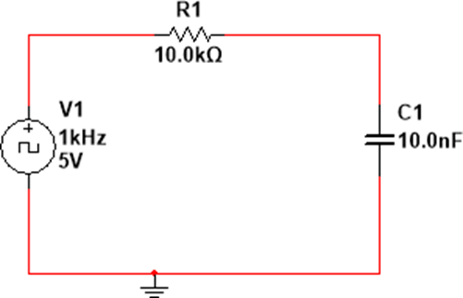

**1.For 1kHz input**

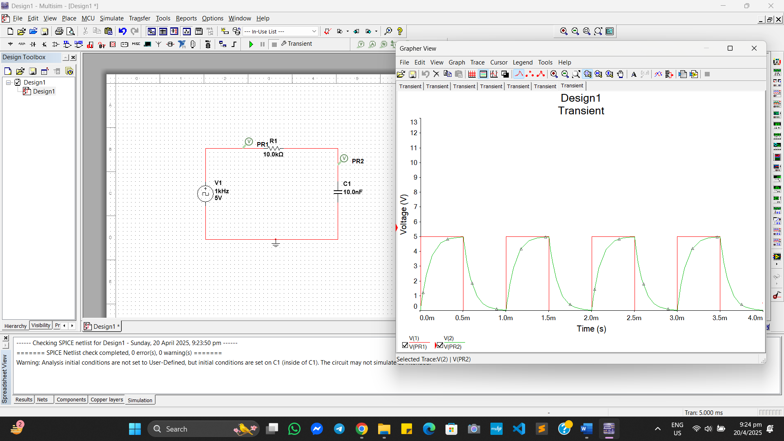

1. The time period T = $\frac{1}{f}$ = $\frac{1}{1000}$ = 1ms
2. The charging curve starts at 0 V and rises towards ~5 V (supply voltage), but **doesn’t fully reach 5 V** before the signal goes low again.
3. Discharging similarly starts near the peak and decays but **doesn’t fully reach 0 V**.
4. Rising Time = 0.5ms and falling time = 0.5ms

At 1 kHz, the capacitor **does not fully charge or discharge** due to a shorter time period compared to the RC time constant. The voltage across the capacitor shows a rounded sawtooth waveform.

**2.For .5kHz input**

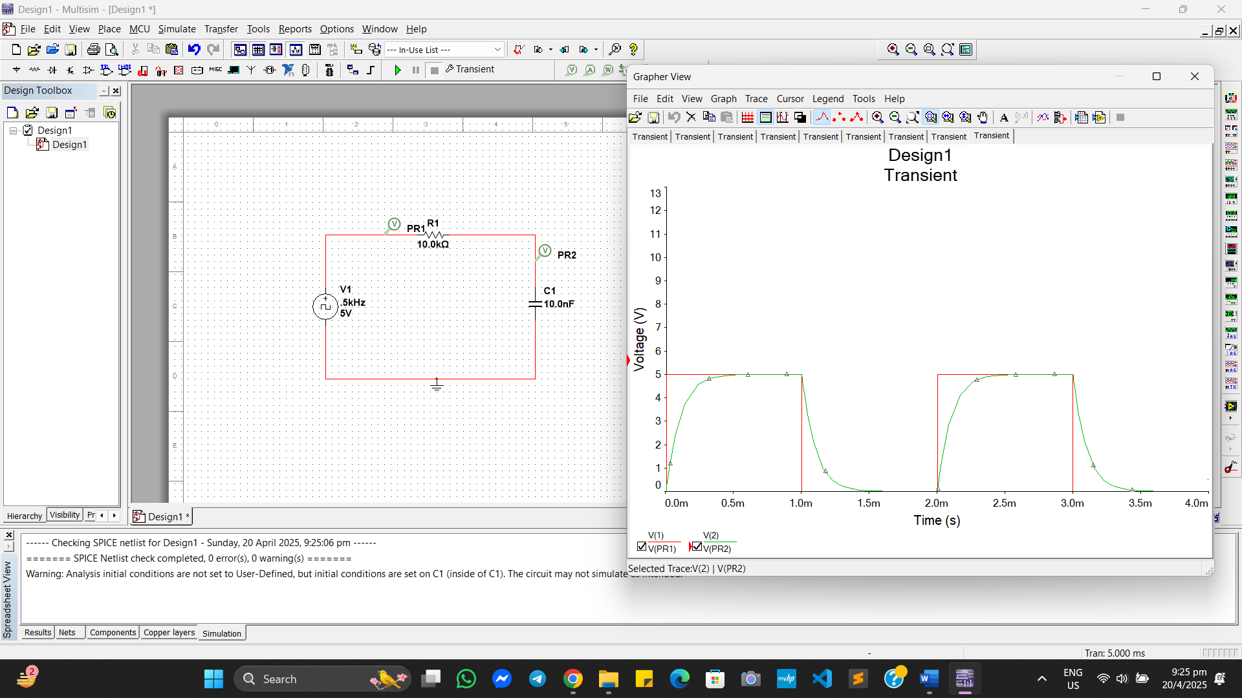

1. The time period T = $\frac{1}{f}$ = $\frac{1}{500}$ = 2ms
2. The capacitor **has more time to charge and discharge**, so the voltage across the capacitor gets **closer to 5 V and 0 V** respectively.
3. Rising Time = 1ms and falling time = 1ms

At 500 Hz, the capacitor gets more time to follow the square wave, so charging/discharging curves are more complete.

**3.For 2kHz input**

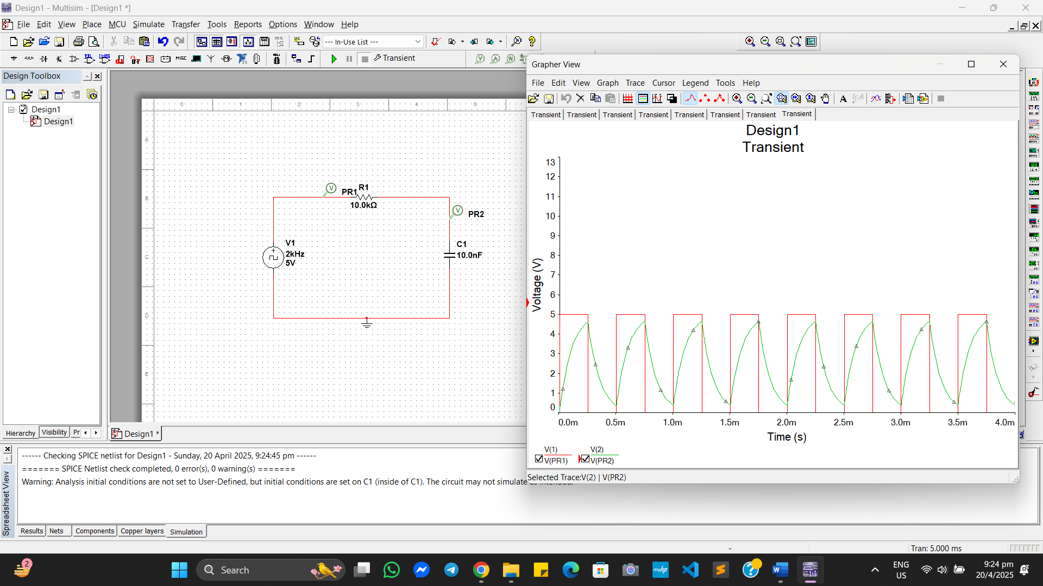

1. The time period T = $\frac{1}{f}$ = $\frac{1}{2000}$ = .5ms
2. The capacitor would **barely charge or discharge**, resulting in a **much smaller voltage swing** and an almost **flat line near zero**.
3. Rising Time = 0.25ms and falling time = 0.25ms

**Result Analysis:**

The experiment aimed to analyze the behavior of a series RC circuit when subjected to a square wave input at different frequencies. Using a resistor of 10 kΩ and a capacitor of 10 nF, the time constant (τ = RC) was calculated to be 0.1 ms. At a frequency of 0.5 kHz (T = 2 ms), the capacitor had sufficient time to charge and discharge fully, resulting in a complete exponential rise and fall in the output voltage. When the frequency was increased to 1 kHz (T = 1 ms), the capacitor only partially charged and discharged during each cycle, producing a waveform with rounded edges. This is due to the reduced time available relative to the time constant. The observations confirm that as the input frequency increases, the capacitor has less time to respond, leading to diminished voltage swings. Overall, the results demonstrate the frequency-dependent nature of the RC circuit, which acts as a low-pass filter by allowing slower signals to pass while attenuating higher-frequency ones.

**Question and answers:**

**1. Charging and Discharging voltage Across the Capacitor**

**1. f = 1 kHz ⇒ T = 1 ms ⇒ t = 0.5 ms = 500 µs**

**t/τ=500/100=5**

**Charging Voltage:**

**VC (t)= vmax(1-e-t/τ)**

**VC = 5(1-e-5) = 5(1-0.0067) = 4.97V**

**Discharging Voltage:**

**VC (t)= vmax(e-t/τ)**

**VC = 5(e-5) = 0.033V**

**2. f = 2 kHz ⇒ T = .5 ms ⇒ t = 0.25 ms = 250 µs**

**t/τ=250/100=2.5**

**Charging Voltage:**

**VC (t)= vmax(1-e-t/τ)**

**VC = 5(1-e-2.5) = 5(1-0.0821) = 4.59V**

**Discharging Voltage:**

**VC (t)= vmax(e-t/τ)**

**VC = 5(e-2.5) = 0.41V**

**3. f = .5 kHz ⇒ T = 2 ms ⇒ t = 1 ms = 1000 µs**

**t/τ=1000/100=10**

**Charging Voltage:**

**VC (t)= vmax(1-e-t/τ)**

**VC = 5(1-e-10) = 5(1-0.000045) = 4.9998V**

**Discharging Voltage:**

**VC (t)= vmax(e-t/τ)**

**VC = 5(e-10) = 0.000225V**

**2.Explain Input-Output Graph for Each Frequency**

|  |  |  |  |
| --- | --- | --- | --- |
| Frequency | Input Shape | Capacitor Voltage | Explanation |
| 0.5 kHz | Square wave (5V) | Smooth rising/falling curves (close to full charge/discharge) | Long enough time to nearly fully charge and discharge |
| 1 kHz | Square wave (5V) | Rising/falling curves, **less complete** than 0.5 kHz | Less time available, so capacitor doesn’t fully charge/discharge |
| 2 kHz | Square wave (5V) | Very shallow curves or flat wave | Time too short for noticeable charging or discharging |

**3. What is Time Constant (τ)?**

* **Formula: τ=R×C**
* **Given:**
  + **R= 10 kΩ =10×103 Ω**
  + **C=10 nF=10×10-9F**

**τ=104×10-8=10-4=0.1ms**

**This means:**

* After 0.1 ms, the capacitor reaches ~63.2% of its final voltage during charging.
* It takes approximately 5τ = 0.5 ms to fully charge or discharge.

**Conclusion:**

In this experiment, we worked with real RC circuits in the lab using components such as resistors, capacitors, connecting wires, a function generator, and an oscilloscope. Our main objective was to observe and understand the charging and discharging behavior of a capacitor in response to a square wave input and how the time constant (τ = RC) affects this behavior. Although we had studied the theory behind RC circuits, performing the experiment with real hardware provided us with valuable practical insight into how these circuits behave in real-time.

We began by assembling the circuit on a breadboard and connecting it to a square wave signal from the function generator. Using the oscilloscope, we carefully monitored the voltage across the capacitor for input frequencies of 0.5 kHz, 1 kHz, and 2 kHz. The oscilloscope clearly showed how the capacitor voltage responded over time—rising and falling exponentially—depending on the frequency of the input signal. At lower frequencies, the capacitor had more time to fully charge and discharge, while at higher frequencies, it only partially responded due to the limited time per cycle.

One key observation was the presence of minor deviations between the theoretical curves and the actual waveforms seen on the oscilloscope. These differences were due to real-world factors such as internal resistance of components, parasitic capacitance, and signal noise. Despite these variations, our results aligned well with theoretical expectations and demonstrated the role of the time constant in shaping the capacitor’s voltage response.

This hands-on experiment not only reinforced our understanding of RC circuits and transient analysis but also improved our skills in using lab equipment like oscilloscopes and function generators. Overall, it provided a valuable bridge between classroom theory and practical electrical engineering applications.